From the Incident page, select the hamburger menu on the upper left and select Export.
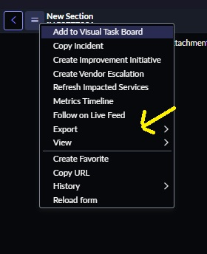

Check the Accessible PDF box and export.
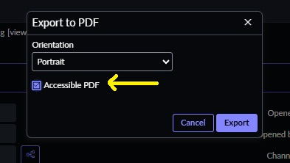

Wait a few seconds, then confirm the download pop-up to download the incident PDF.

